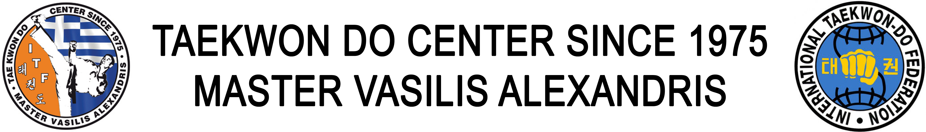

The 14th SUMMER CAMP TAEKWON DO ITF is going to take place from 2 to 9 of August by Master Alexandris Vasilis 8th degree at OLYMPIOS ZEUS bungalows in Greece, 50m from seaside at the wonderful location of Plaka Litohorou, just under the famous mountain Olympus and 80 km from Thessaloniki. You can reach easily the camp from Thessaloniki by train or by car or even by bus. The Moto of the camp is “See + Sun + Mountain + Sightseeing + Taekwon Do Training”.
The cost per person is 350€ including 7 nights in double rooms, breakfast and meal or lunch. All rooms have Air-condition, TV, refrigerator and private bathrooms with shower. http://www.olympios-zeus.gr/360view.asp?path=icon/panorama_olympios.swf
Training program
Monday Free
Tuesday 9-11 & 19-21
Wednesday 19-21
Thursday 9-11 & 19-21
Friday 19-21
Saturday 19-21 & Soccer
For participations please contact Master Alexandris Vasilis at
master_alexandris@yahoo.gr

Limited rooms. Participations until 30 of June.

